ORD

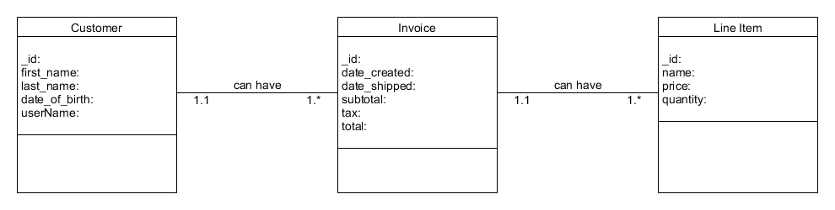

NoQSL Data Structure

